|  |
| --- |
| Milestone 3 |
| Business Buccaneers: William Kozel (Systems Analyst), Johann Quintero (Business Analyst), Jack Fentke (Programming Coordinator), Paige Lowery (Project Manager) |

|  |
| --- |
| 10-18-2017 |

Table of Contents

Executive Background 3

Current Business Environment 4

Problems with Current System 4

Proposed System Objectives and Constraints 5

Business Benefits 5

Stakeholders 5

Use Case Package 6

Executive Summary 6

Context Diagram 6

Use Case Diagram 7

Use Case Specifications 8

Use Case – 1 (Login) 8

Use Case – 2 (Manage Account) 9

Use Case – 3 (Manage Point Balance) 10

Use Case – 4 (Generate Report) 13

Use Case – 5 (Manage Redeemable Rewards) 14

Use Case – 6 (Manage Item Point Values) 15

Functional Requirements 16

Non-Functional Requirements 16

Hardware/Software Specifications: 17

Standard Naming Convention 17

Complete Data Flow Diagram Package 18

Data Flow Diagram Level 0 18

Data Flow Diagram – Level 1 18

Manage Accounts 19

Manage Redeemable Rewards 19

Manage Item Point Value 19

Data Flow Diagram – Fragments 21

Entity Relationship Diagram 22

Navigation Diagram 23

Program Plan 24

Mock Forms 33

Login 33

Manage Accounts 34

Owner Menu 35

Customer Ordering Form 36

Generate Reports 37

Sample Reports 38

# Executive Background

The following document for On The Square’s Information System includes the history of the business and explains business methods currently being utilized and our plans for the new system. Our team will provide information about our proposed system and its expected benefits for the company. The document will also provide other requirements needed to build this information system including functional and nonfunctional requirements as well as context diagrams, and our full use case package.

On The Square opened their doors in October 2003 as a small tapas bar and lounge in Tarboro, North Carolina. The restaurant was already not following the typical southern dining practices that most people were used to in Eastern NC; but when they received such success from the start of the business, they decided to take it a step further and transform the restaurant into a “quintessential urban bistro, without the urban”. Now, almost 14 years later, they are serving dishes with seasonal and sustainable ingredients from all over NC, and local fishermen for their seafood. On The Square has attracted patrons from all over the United States, but they also maintain a strong local customer base. Although the leading reason they have been able to keep their doors open is the amazing food; another thing that keeps customers coming back and recommending this restaurant is the southern hospitality that they receive from the minute they walk through the door, until they leave. The restaurant is open Monday through Friday for lunch, which is a more casual dining experience, and they open for dinner Thursday through Saturday for a fine dining atmosphere.

Based on our conceptual walk-through in Milestone 1, we have decided as a team to stick to a web based project that will revamp the entire restaurants current website. We will create a site that will allow customers to do all of the projected features that we presented in our first Milestone.

# Current Business Environment

On The Square is a small business that is independently owned and operated by husband and wife, Stephen and Inez Ribustillo. Stephen is the executive chef and creates and designs all of the items on the menu, while Inez is a Master Sommelier and runs the retails wine room in the front of the restaurant. There are around 30 employees that rotate working each week. The staff includes 2 full-time managers, a kitchen manager and a dining room manager, that work directly with Stephen and Inez to make sure that the restaurant is ran properly. On The Square is a small fine dining restaurant that utilizes local superior ingredients to elevate classic southern dishes. Although the Ribustillo family runs a successful small business, there is room for improvements. Their customer base for the most part is locals that live within a 30-mile radius of Tarboro, North Carolina; any out of town customers are usually first time diners or do not come back often. There is no incentive to get customers coming back to the restaurant and there is little to no customer relations program.

# Problems with Current System

The current systems for customer relations consist of a VIP system through email. The system works by allowing customers to become VIP after using their email to book a certain amount of reservations. The customers become VIP in the system but nothing extra is given to them because of this, making them the same as any other customer. Without a proper customer relations system, the company will never be able to fully develop a beneficial relationship with their customers.

As of right now, the VIP program is the only thing On The Square utilizes to create a customer program. There is no loyalty program and nothing that allows customers to get updates about promotions or new menu items.

# Proposed System Objectives and Constraints

The objective of this system is to increase customer loyalty and to spark excitement in loyal, and infrequent, patrons of On the Square through a CRM. Our CRM will promote new menu items, offer discounts, and offer points to loyalty members who continue to patron our store. This will boost and bolster current sales figures and increase store profits. This will help On the Square grow from a small local eatery to a larger regional location that people will drive from miles around to enjoy. Additionally, we want to better display On the Square and what they have for offer to potential customers. In terms of skill and total ability.

Our constraints are our team size, On the Square’s budget, On the Square’s schedule, On the Square’s dedication to new technological systems that are new and different, and our team’s coding experience. We believe that these are goals we can work through and overcome.

# Business Benefits

A CRM gives the ability to collect and manage customer information to see their past visits and preferences. The use of this system can give On The Square an option to send coupons and rewards to customers individually as part of a customer loyalty program. This will allow more attention to each customer and potentially result in more frequent visits to the business. This kind of program can allow customers to interact with the business and increase the diversity of customers to more than just locals.

# Stakeholders

The primary stakeholders are those who are directly involved with On The Square. This includes the owner, the employees who work there, and the customers who patron the restaurant. Other stakeholders include other local restaurants that are considered the restaurant’s competitors

# Use Case Package

## Executive Summary

This is a comprehensive analysis of On The Square restaurant’s information system that concentrates on determining and evaluating the requirements for the system. Included in this analysis is a context diagram of On The Square’s information system, which is a high level view of the proposed system that defines the boundaries between the system, part of the system, and its environment, showing the entities that interact with it and the data flow between them. Also the analysis contains the use case diagram of the system that identifies, clarifies, and organizes the requirements and who interacts with their system including actors, use cases, and supporting actors. The use case specifications are analyzed last in the document and highlight the requirements for how a user will interact with the system to achieve value. This document should outline the requirements, actors, preconditions, flow of events, normal flow, and alternative flows of each use case for On The Square’s new proposed system.

## Context Diagram

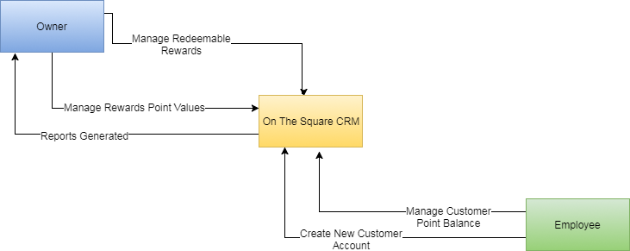

## Use Case Diagram

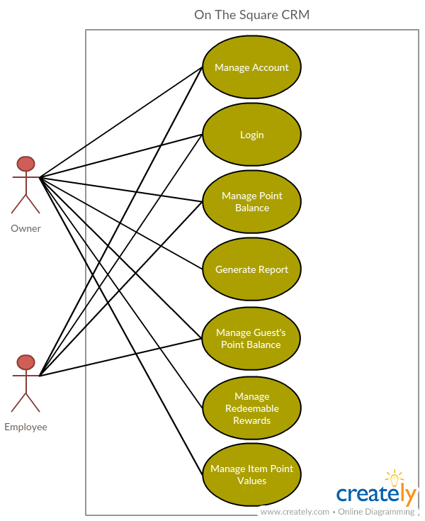

## Use Case Specifications

Use Case – 1 (Login)

|  |  |  |  |  |
| --- | --- | --- | --- | --- |
| Use Case Name:  Login | ID:  UC - 1 | | Priority:  High | |
| Actor: Staff (Owner/Employees) | | | | |
| Description: Allows the actor to gain access to the system and the information specific to that actor | | | | |
| Trigger: User login  Type: ☒ External ☐ Temporal | | | | |
| Preconditions: Staff has PIN assigned by Owner | | | | |
| Normal Course:   1. User attempts to log into the system 2. Enters their assigned PIN 3. System accepts request to access  * If User has Owner login they will be granted access to more menu options that are not privy to employees  1. User is now logged in | | | | **Information for Steps:**    PIN (Five Digits) User access granted |
| Alternative Courses:   1. Staff enters the wrong PIN    1. Prompted to Try Again | | **Information for Alt. Course:**  PIN (Five Digits) | | |
| Postconditions:  1. Owner has access to complete system  2. Staff can view and manage all information other than reports and specific item point values | | | | |
| Exceptions:  Staff PIN is Pre-Existing  Owner will always have access to entire system   |  |  |  |  | | --- | --- | --- | --- | | Summary Inputs:  PIN (Five Digits) | Source:  Staff | Outputs:  User access granted | Destination:  Staff/CRM | | | | | |

### Use Case – 2 (Manage Account)

|  |  |  |  |  |  |
| --- | --- | --- | --- | --- | --- |
| Use Case Name:  Manage Account | | ID:  UC - 2 | | Priority:  High | |
| Actor: Staff (Employee or Owner) | | | | | |
| Description: This use case is for the staff to create a Guest Account | | | | | |
| Trigger: New Guest Account needs to be created on-site.  Type: ☒ External ☐ Temporal | | | | | |
| Preconditions:  Staff has a valid login and acquired Guest Information | | | | | |
| Normal Course:   1. Staff logs into CRM 2. Selects "Create Guest Account" 3. The Staff adds a new Guest to the CRM with their information. 4. The CRM asks for confirmation 5. Staff confirms the account creation 6. New Account created 7. Staff logs off | | | **Information for Steps:**  Staff log in information  Guest information, Name, ZIP, Phone Number, DOB, Email  New Guest Account | | |
| Alternative Courses:   1. Staff selects the wrong button 2. Staff goes to previous screen and selects "Create Guest Account" | | | **Information for Alt. Course Steps:** | | |
| Postconditions:  New Guest Account is created | | | | | |
| Exceptions:  None | | | | | |
| Summary Inputs:  Staff Log on  Guest Name, ZIP, Phone Number, DOB, Email | **Source:**  Staff  Guest | | **Outputs:**  New Guest Account | | **Destination:**  Data Store |

Use Case – 3 (Manage Point Balance)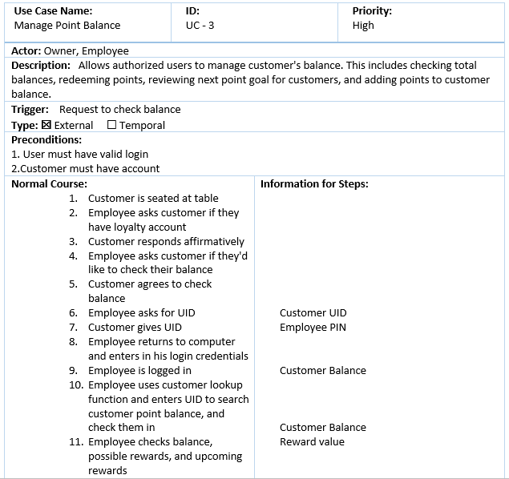

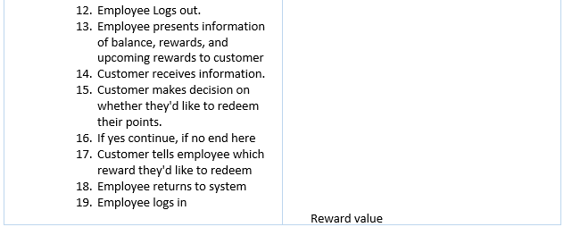

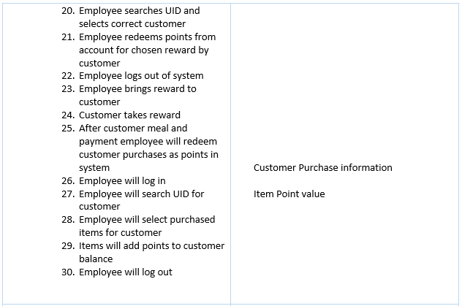

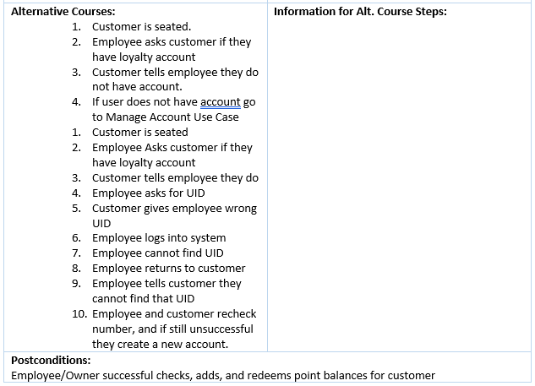

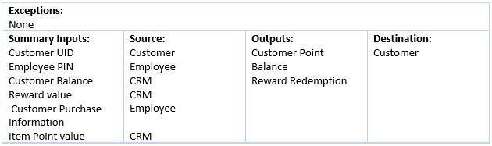

### Use Case – 4 (Generate Report)

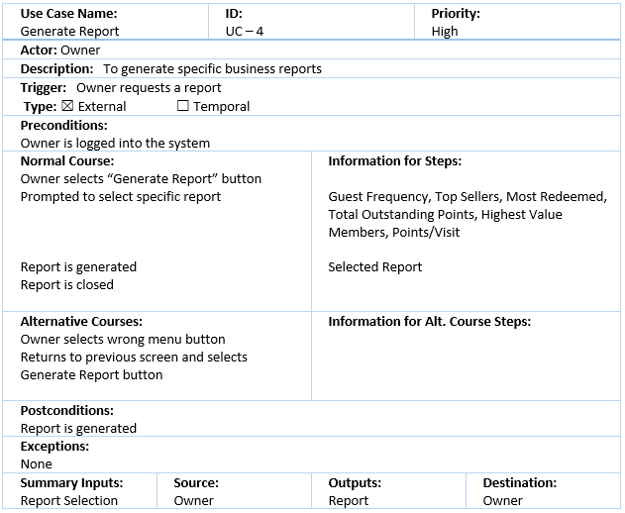

### Use Case – 5 (Manage Redeemable Rewards)

|  |  |  |  |  |  |
| --- | --- | --- | --- | --- | --- |
| Use Case Name:  Manage Redeemable Rewards | | ID:  UC-5 | | Priority:  Medium | |
| Actor: Owner | | | | | |
| Description: Create and delete redeemable rewards Guests can claim based on point value system | | | | | |
| Trigger:  Type: ☒ External ☐ Temporal | | | | | |
| Preconditions:   1. User has correct credentials 2. Owner sees need to update redeemable items 3. Owner is logged into system | | | | | |
| Normal Course:   1. Owner selects "Reward Options" 2. Owner edits and manages new and old rewards, assigns points, and checks number of redemptions. 3. Owner saves and closes window 4. Owner logs out | | | **Information for Steps:**  New reward options  Updated reward options | | |
| Alternative Courses:  1. User forgets to save options before logging out  2. Window asks user if he'd like to save before exiting   1. Owner tries to save duplicate reward 2. System warns user item already exists | | | **Information for Alt. Course Steps:**  Warning Message  Duplicate reward information  Warning Message | | |
| Postconditions:  System reward options are updated | | | | | |
| Exceptions: | | | | | |
| Summary Inputs:  New Reward Options  Duplicate reward information | **Source:**  Owner  Owner | | **Outputs:**  Updated Reward Options  Warning Message | | **Destination:**  CRM  Owner |

### Use Case – 6 (Manage Item Point Values)

|  |  |  |  |  |  |
| --- | --- | --- | --- | --- | --- |
| Use Case Name:  Manage Item Point Values | | ID:  UC-6 | | Priority:  Medium | |
| Actor: Owner | | | | | |
| Description: Assign point values to new and old menu items for guests to earn. | | | | | |
| Trigger:  Type: ☒ External ☐ Temporal | | | | | |
| Preconditions:   1. Owner is logged into the system 2. New Menu Items to be added | | | | | |
| Normal Course:   1. New Item is added to physical menu 2. Owner selects "Item Values" option 3. Owner selects "New Item" 4. Owner fills out information about new menu item 5. Owner adds decided point value to menu item 6. Owner saves item 7. Owner logs out | | | **Information for Steps:**  New Menu Item  New Menu Item information  Item Point Value  New CRM menu item and point value | | |
| Alternative Courses:   1. User enters item already existing 2. System asks user if they'd like to update existing item 3. User selects yes or no to update new Item. | | | **Information for Alt. Course Steps:**  Old Menu Item  Old Menu Item Info | | |
| Postconditions:  Menu Item value is updated and assigned | | | | | |
| Exceptions: | | | | | |
| Summary Inputs:  New Menu Item Information  New Menu Item  Item Value | **Source:**  Restaurant  Owner  Owner | | **Outputs:**  New Item  New Item Point value  Old Menu Item Information | | **Destination:**  CRM  CRM  CRM |

## Functional Requirements

· The system must run on C# and Access (Software our team is comfortable working in)

· The system must have the ability to store local data

· The system must be able to take user credentials to avoid fraudulent entries

· The system must be able to produce reports for benefit of the managers

· The system must be able to recognize incomplete entries and prompt for completion

· The system must run on Windows 7 or higher

· The system must allow users to edit records and add new users

## Non-Functional Requirements

· The system shall run on Chrome, Firefox, Safari and Internet Explorer

· The system shall be able to run on iOS 8 or later

· The system shall be able to run on Android KitKat or later

· The system shall be available at 99.9% uptime

· The system shall be able to download full database backups daily

|  |  |
| --- | --- |
| Reliability | High user testing to ensure uptime during heavy business hours |
| Serviceability | Needs to be easily worked on so that the user can correct errors |
| Scalable | Must be able to accept large number of menu items, guests, and reward items |
| Usable | System shall be easily understood by staff with little knowledge of CRMs |
| Secure | System shall be able to easily perform backups of data |
| Modern | System shall be able to run on current PC hardware |

When we are building the system for On The Square we need to be sure that we are creating a system they can really use, and one that will meet their daily needs and requirements. The system must maintain a **reliable** characteristic, the user shouldn’t expect the system to shut down during peak hours, or cut out on them at pivotal high traffic moments of the day. During the rare moments that the user may experience an error it should be easily fixed and **serviced** within the architecture software, meaning system downtime shouldn’t be expected to go for over 40 minutes if an error occurs. For the majority of the time though we want our system to be running, and while it’s running we want our users to actually **use** the system and have good GUI experience. And after their use we want them to be able to backup and **secure** the data they entered so they can expect to see it in the same place the next day. We are also requiring this system to run on **modern** hardware and software so that in the case our client does want to **up scale** the system.

## Hardware/Software Specifications:

The software for is being designed in C# so the computer will need the following specs based on C# software requirements, database editing requirements, and preliminary knowledge from the team’s experience with C# based programs.

Software:

• Microsoft Windows 10

• Microsoft .NET Framework 4.6 (Or Higher)

• Microsoft Access

Hardware:

• Core i5 processor

• 1920X1080 monitor

• DVI video output

• USB Keyboard & Mouse

• Ethernet connection

## Standard Naming Convention

* Standard C# Naming

# Complete Data Flow Diagram Package

## Data Flow Diagram Level 0

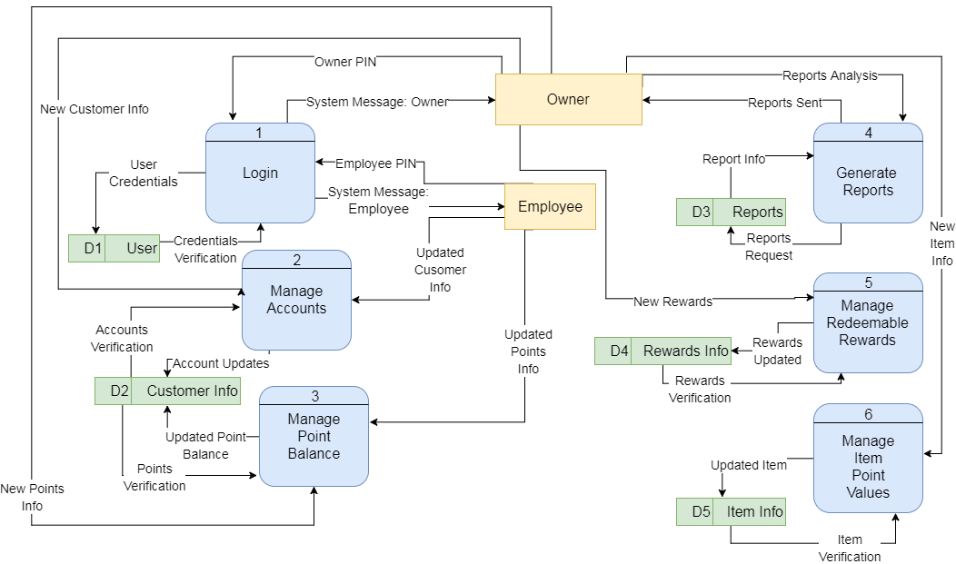

## Data Flow Diagram – Level 1

### Manage Accounts

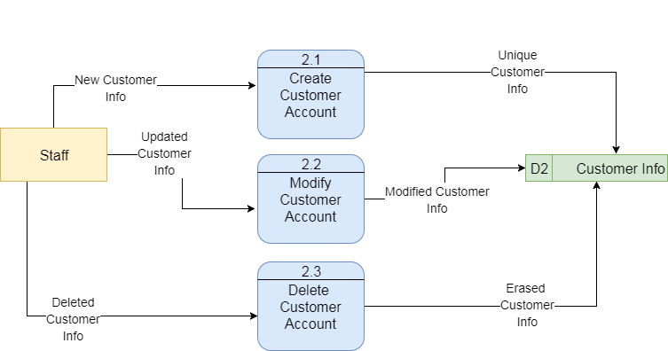

### Manage Redeemable Rewards

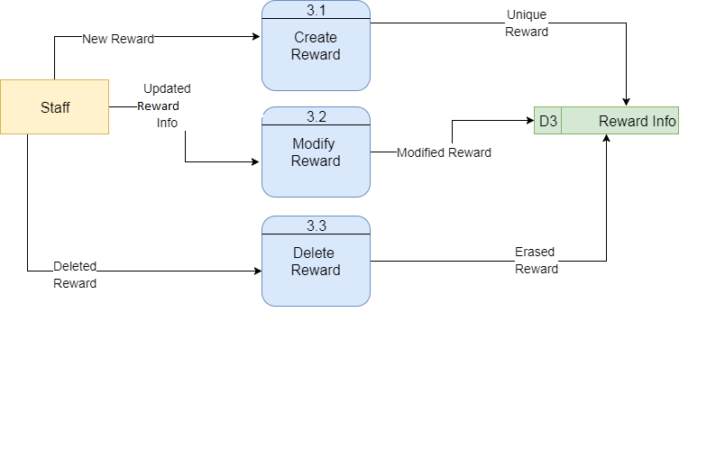

### Manage Item Point Value

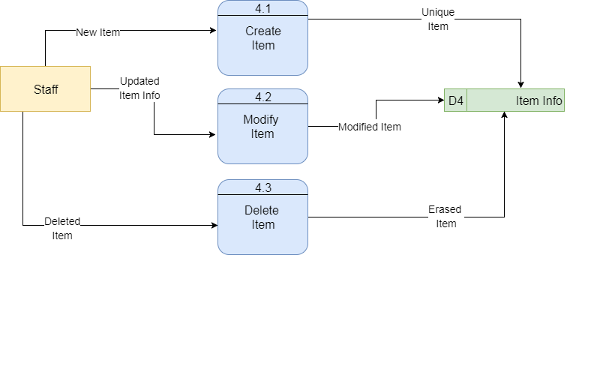

## Data Flow Diagram – Fragments

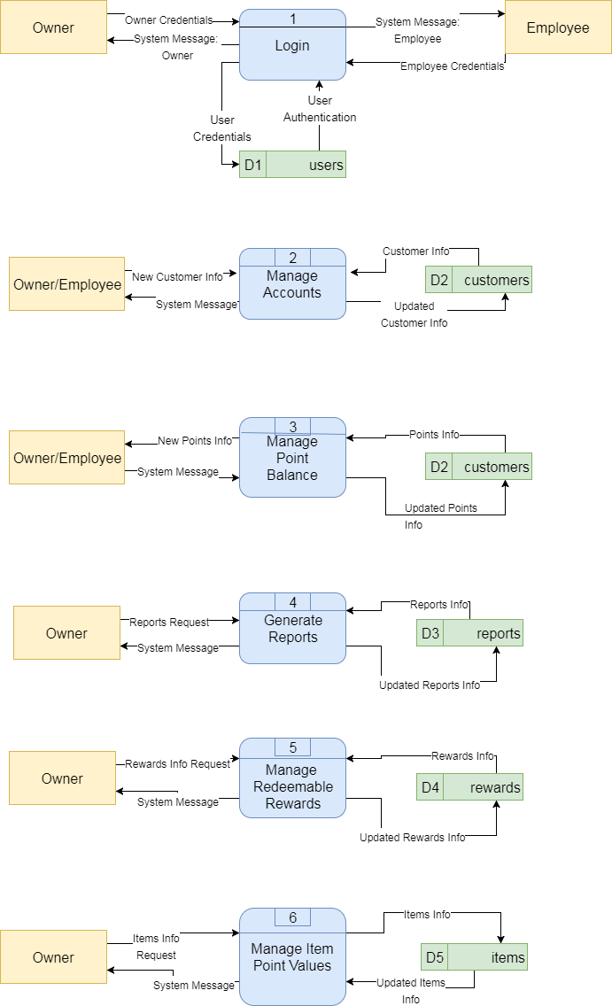

# Entity Relationship Diagram

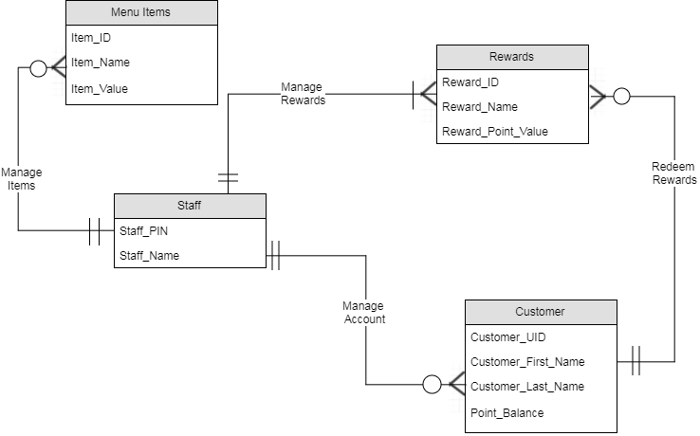

# Navigation Diagram

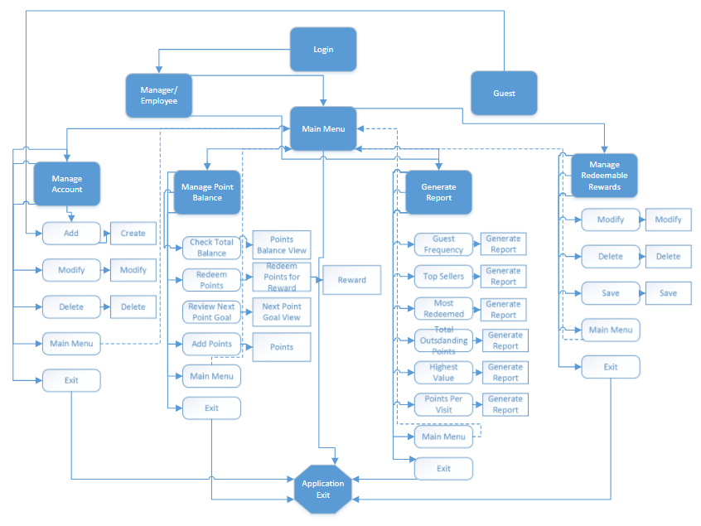

# Program Plan

|  |  |  |  |
| --- | --- | --- | --- |
| **Form/Menu/Report** | **Input** | **Process** | **Output** |
| **Main Menu** | Manage Account Menu Select | Transfer to Manage Account menu | Load menu form |
|  | Login Menu Select | Transfer to Login Menu | Load menu form |
|  | Manage Point Balance Menu Select | Transfer to Manage Point Balance Menu | Load menu form |
|  | Generate Report Menu Select | Transfer to Generate Report Menu | Load menu form |
|  | Manage Redeemable Rewards Menu Select | Transfer to Manage Redeemable Rewards Menu | Load menu form |
|  | Manage Item Point Values Menu Select | Transfer to Manage Item Point Values Menu | Load menu form |
|  | Exit Select | Pop up message asking user "Are you sure you want to exit?” | Message Box |
|  |  | If user selects “Yes”, system closes | Application Closes |
|  |  | If user selects “No”, message box closes and stays on main menu form | Load main menu form |
| **Manage Account** | Form Load | Pull list of existing guest accounts from database and populate in Select Existing User drop box | Existing Guest Accounts List |
|  | Add Select | Test if user entered a new account name in “Create Guest Account” text box | Validation of text |
|  |  | If text contains value, pass to Add New Guest Form | Load Add New Guest Form and Pass New Guest Name and Phone Number Value |
|  |  | If text box does not contain a value, message user to enter a value | Message Box |
|  | Select Existing Guest drop box select | User selects from existing Guest Accounts | Guest Account Selection |
|  | Modify Select | Validate user has selected existing Guest Account | Validation of text |
|  |  | If selected, load Modify Guest Account form | Load Modify Guest Account Form |
|  |  | If no selection, message user to select existing Guest Account | Message Box |
|  | Delete Select | Validate user has selected existing Guest Account | Validation of text |
|  |  | If selected, load Delete Guest Account form | Load Delete Guest Account Form |
|  |  | If no selection, message user to select existing Guest Account | Message Box |
|  | Main Menu Select | Transfer to Main Menu | Load Main Menu Form |
| **Create Guest Account** | Enter form values | Populate Guest Account from Manage Account menu | Guest First Name, Last Name, Phone Number, User ID |
|  |  | User fills in values | none |
|  | Create Select | Validate form entries for required fields and correct data types | Validated data |
|  |  | If any required values are missing or values contain incorrect data types, message user to resolve | Message Box |
|  |  | If all required values are populated and contain valid data types, add guest to database | New Guest Account |
|  | Manage Account Menu Select | Transfer to Manage Account Menu | Load Manage Account Menu |
|  | Main Menu Select | Transfer to Main Menu | Load Main Menu Form |
| **Modify Existing Guest** | Form Load | Populate all values from database for selected guest account | Load data values for guest account |
|  | User Edits Values | System displays all altered values | New Values |
|  | Modify Select | Validate form entries for required fields and correct data types | Validated Data |
|  |  | If any required values are missing or values contain incorrect data types, message user to resolve | Message Box |
|  |  | If all required values are populated and contain valid data types, modify in database | Modified Guest Data |
|  | Manage Account Menu Select | Transfer to Manage Account Menu | Load Manage Account Menu |
|  | Main Menu Select | Transfer to Main Menu | Load Main Menu Form |
| **Delete Existing Guest** | Form Load | Populate all values from database for selected guest account | Load data values for guest account |
|  | Delete Select | Message User “Are you sure you want to delete this guest?” | Message box |
|  |  | If user selects “Yes”, remove all guest data from database | Removed Data |
|  |  | If user selects “No”, return to form | Reload Form |
|  | Manage Account Menu Select | Transfer to Manage Account Menu | Load Manage Account Menu |
|  | Main Menu Select | Transfer to Main Menu | Load Main Menu Form |
| **Login** | Employee enters five-digit pin | Validate correct pin number | Validation of Pin Number |
|  |  | If pin number is incorrect, system prompts user to “Please Try Again” | Message Box |
|  |  | If pin number is correct, system grants access to user | Load Main Menu |
| **Manage Point Balance** | Manage Point Balance Menu Select | Transfer to Manage Point Balance Menu | Load Manage Point Balance Menu |
|  | Check Total Balance Select | Transfer to Check Total Balance Form | Load Check Total Balance Form |
|  | Redeem Points Select | Transfer to Redeem Points Form | Load Redeem Points Form |
|  | Review Next Point Goal Select | Transfer to Review Next Point Goal Form | Load Next Point Goal Form |
|  | Add Points to Customer Balance Select | Transfer to Add Points to Customer Balance Select | Load Add Points to Customer Balance Form |
|  | Main Menu Select | Transfer to Main Menu | Load Main Menu Form |
| **Check Total Balance** | Form Load | Populate all values from database for guest accounts | Load data values for guest accounts |
|  | Enter Guest Account User ID in search bar | Populate all values from database for Guest Account associated with User ID | Load data values for Total Points Balance |
|  |  | If User ID does not exist, system displays “There is no account associated with that User ID” | Message Box |
|  |  | If User ID exists, system displays guest information and total points balance | Load Guest data values and Total Points Balance |
|  | Manage Point Balance Select | Transfer to Manage Point Balance Menu | Load Manage Point Balance Menu |
|  | Main Menu Select | Transfer to Main Menu | Load Main Menu Form |
| **Redeem Points** | Form Load | Populate all values from database for guest accounts | Load data values for guest accounts |
|  | Enter Guest Account User ID in search bar | Populate all values from database for Guest Account associated with User ID | Load data values for Total Points Balance |
|  |  | If User ID does not exist, system displays “There is no account associated with that User ID” | Message Box |
|  |  | If User ID exists, system displays guest information and total points balance | Load Guest data values and Total Points Balance |
|  | Redeem Points for Reward Select | Transfer to Rewards Selection page | Load Rewards Selection page |
|  | Select Reward | Subtract points associated with reward from guests account in database | Updated Points Balance |
|  |  | If not enough points in guest account to redeem selected reward, system displays “You do not have enough points to redeem this reward” | Message Box |
|  |  | If enough points are in the guest account to redeem selected reward, system displays “Your remaining points balance is ____” | Message Box |
|  | Manage Point Balance Select | Transfer to Manage Point Balance Menu | Load Manage Point Balance Menu |
|  | Main Menu Select | Transfer to Main Menu | Load Main Menu Form |
| **Review Next Point Goal** | Form Load | Populate all values from database for guest accounts | Load data values for guest accounts |
|  | Enter Guest Account User ID in search bar | Populate all values from database for Guest Account associated with User ID | Load data values for current rewards and associated point values |
|  |  | If User ID does not exist, system displays “There is no account associated with that User ID” | Message Box |
|  |  | If User ID exists, system displays current rewards and associated point values | Load data values for current rewards and associated point values |
|  | Manage Point Balance Select | Transfer to Manage Point Balance Menu | Load Manage Point Balance Menu |
|  | Main Menu Select | Transfer to Main Menu | Load Main Menu Form |
| **Add Points to Customer Balance** | Form Load | Populate all values from database for guest accounts | Load data values for guest accounts |
|  | Enter Guest Account User ID in search bar | Populate all values from database for Guest Account associated with User ID | Load data values for points available to add |
|  |  | If User ID does not exist, system displays “There is no account associated with that User ID” | Message Box |
|  |  | If User ID exists, system displays current rewards and associated point values | Load data values for current rewards and associated point values |
|  | Points select determined by price of meal | Populate points data value in database for associated User ID | Updated points value in database |
|  | Manage Point Balance Select | Transfer to Manage Point Balance Menu | Load Manage Point Balance Menu |
|  | Main Menu Select | Transfer to Main Menu | Load Main Menu Form |
| **Generate Report** | Guest Frequency Select | Gather Frequency of Guest accounts from database | Generate Report |
|  | Top Sellers Select | Gather most selected item on menu from database | Generate Report |
|  | Most Redeemed Select | Gather most redeemed award from database | Generate Report |
|  | Total Outstanding Points Select | Gather Total Outstanding Points from database | Generate Report |
|  | Highest Value Members Select | Gather guest names and points from Highest to least from database | Generate Report |
|  | Points Per Visit Select | Gather guest names and points per visit from database | Generate Report |
|  | Main Menu Select | Transfer to Main Menu | Load Main Menu Form |
| **Manage Redeemable Rewards and Point Values** | Reward Options Select | Populate data values with current rewards, associated points, and number of redemptions from database | Load Data Values |
|  | User Edits Name of Reward and Associated Points Values | System displays all altered values | New Values |
|  | Save Select | Update and save values in database | Saved and Updated Values |
|  |  | If duplicate item exists, system warns user “Item already exists” | Message Box |
|  | Main Menu Select | Transfer to Main Menu | Load Main Menu Form |

# Mock Forms

## Login

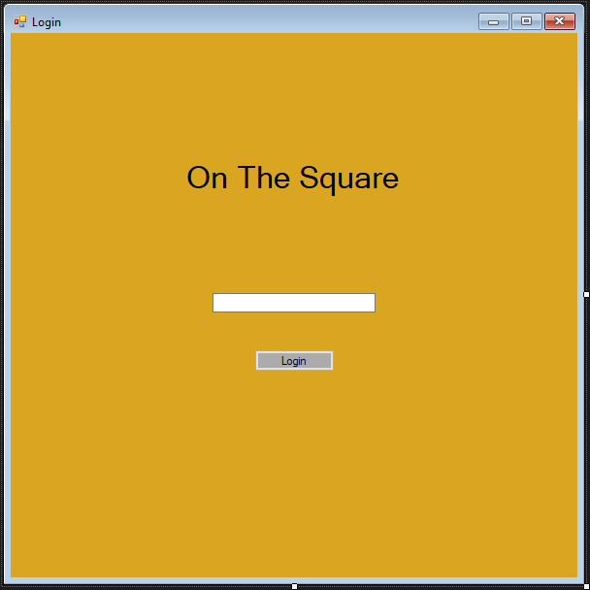

## Manage Accounts

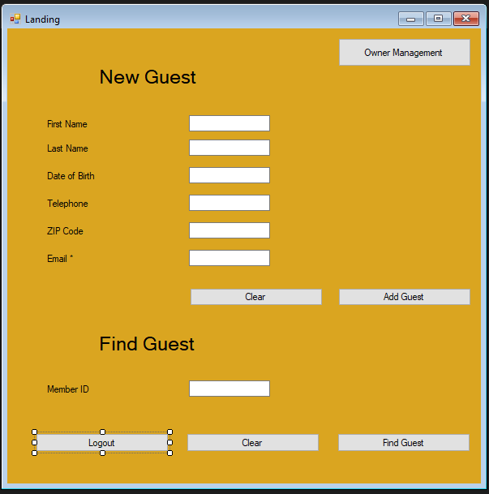

## Owner Menu

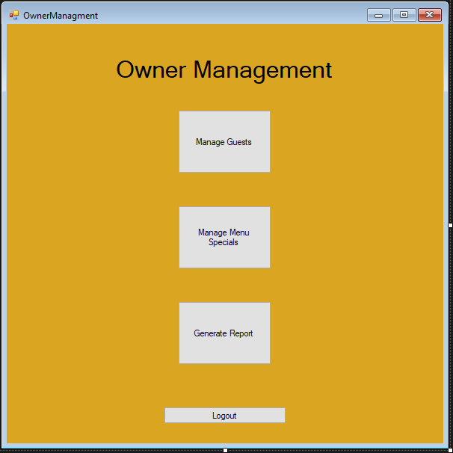

## Customer Ordering Form

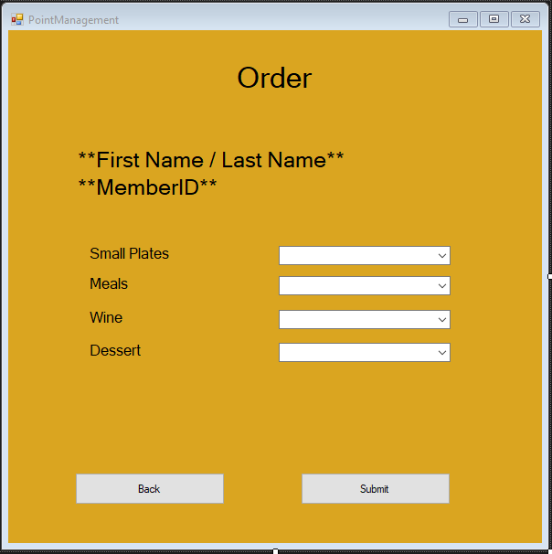

## Generate Reports

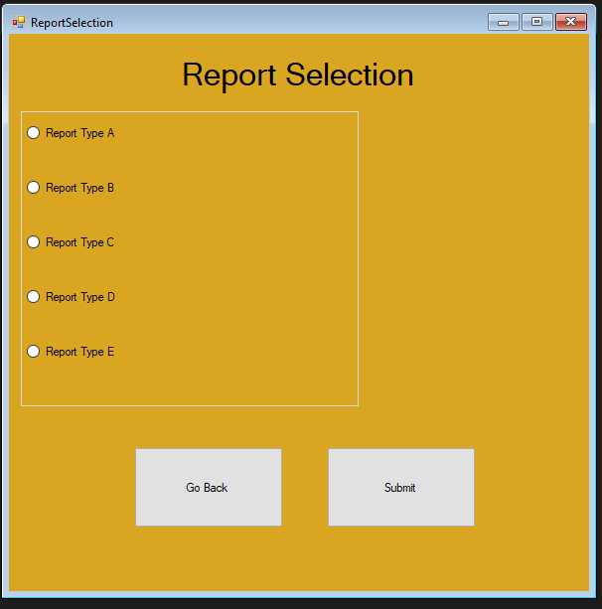

# Sample Reports

